**BOMA FLORIDA STRATEGIC PLAN**

**for the period 2020 - 2023**

**TABLE OF CONTENTS**

1. Cover Page
2. Overview (Organizational Description, Mission, Vision and Values)
3. Goals and Milestone Calendar

**EXECUTIVE SUMMARY**

In early 2015, the BOMA Florida Executive Committee and Governors sought to develop this plan. We worked on and developed portions of the plan with local boards to capture a comprehensive input base. Editing of the plan to a concise, cohesive philosophy of governance continues through 2020, when this finalized plan will be implemented.

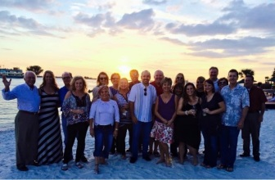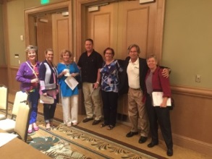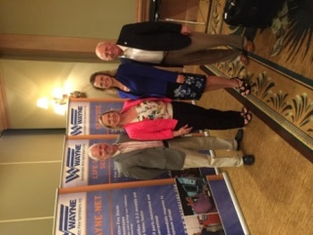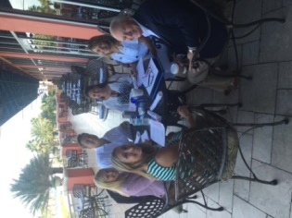

**Governors’ Authorizations**

*Passed by affirmative vote of Governors and Officers at the BOMA Florida Annual Meeting held in September 2016 at the Casa Monica in St. Augustine, FL.*

1. **Overview**

**Organizational Description**

The Building Owners and Managers Association of Florida (BOMA Florida) is a powerful commercial real estate association with seven local associations serving 1,000+ members in the state of Florida. BOMA Florida contributes to advocacy efforts, including regulatory, legislative, and judicial proceedings, in order to help commercial real estate owners, save money, create jobs, and set standards within our buildings. Read more about our *Codes Successes* and *Contributions to the Economy* in Florida. BOMA Florida stays connected and influential at local, state, and national levels on advocacy, sustainability, best practices, and more. All seven BOMA local associations in Florida are affiliated with BOMA International, a federated association based in Washington, D.C. Learn more about BOMA International by visiting [www.boma.org](http://www.boma.org).

**Mission Statement**

To advance a vibrant commercial real estate industry in Florida

through advocacy, influence, and knowledge.

**Vision Statement**

BOMA Florida’s influence and reach will enhance commercial real estate’s image and status as a business and career choice.

**Values Statement**

INTEGRITY, HONESTY & RESPECT: Always do what is fair, right, and ethical while establishing credibility and trust.

COMMUNICATION & TEAMWORK: Share information in an open manner to promote efficient and effective results.

LEADERSHIP, ATTITUDE & ACCOUNTABILITY: Lead with an enthusiastic and positive energy sensitive to the impact to others.

PROFESSIONAL & ENTREPRENEURIAL DEVELOPMENT: Encourage, promote, and recognize innovative and dynamic forward-thinking.

CONFIDENCE & SATISFACTION: Advocate and endorse a culture of tenacity to exceed appropriate expectations.

1. **Goal Areas & Milestone Calendar**

**Encouraging/Asks of Locals**

* Sister Orgs as Conduit
* Attend City Council Meetings
* Build Codes Relationships
* Support IDF/PAC
* Invite Lawmakers to Events
* Talent Recruitment into CRE
* FL Committee Particpation

**BOMA Florida Officers & GA Committee**

* Communication
  + Website Enhancements
  + Social Media Presence Oversight
  + Press Releases Oversight
  + Hand Written Notes
  + Member Survey
  + Newsletter Oversight
* Events
  + Weekly Coordination Calls
  + Host Monthly Calls
  + Expanded Annual Meeting >1.5d
  + Host FL Meetings at Conventions
  + Annual Advocacy Day
  + Legislator of the Year Award
* Logistics
  + Policy Creation
  + Budgeting
  + Staff Oversight (Lobbyist/BAE)
  + Encourage Member Advancement
  + Lead Strategic Planning
  + Fiduciary/Fin’l/Bylaws Oversight
* Clearinghouse
  + Best Practice Sharing Among Govs

**BOMA Florida Committees**

* Draft Model Legislation
* Commissions Service (FBC/Elev)
* Networking Opport. (Events)
* Analyze Session Bills
* Create Position Papers
* Share at BOMA FL Meetings
* Coordinate Calls to Action
* Newsletters

**BOMA Florida Members**

* Grassroots Support

|  |  |  |  |
| --- | --- | --- | --- |
| **BOMA Florida Milestone Calendar - 2020** | | | |
| **1Q20** | **January** | **February** | **March** |
|  | * Identify expiring commission seats for 2020 * Track Bills * LOTY Process * Statewide Call | * Track Bills * Advocacy Day/LOTY Award * Press Release * WBM * Blog Entry * Statewide Call | * Track Bills * Statewide Call * Publish Financial Report * Issue Activation Avenues |
| **2Q20** | **April** | **May** | **June** |
|  | * SRC | * Statewide Call * BAE Review/Renewal | * June Conference * Publish Financial Report |
| **3Q20** | **July** | **August** | **September** |
|  | * Statewide Call | * BAE Conference * Issue Activation Avenues * Statewide Call * Budget creation | * Annual Meeting * Publish Financial Report * Strategic Plan Review |
| **4Q20** | **October** | **November** | **December** |
|  | * Statewide Call * Gov App * Member/Meeting Survey | * Lobbyist Review/Renewal | * Consider Model Legislation * Statewide Call * Publish Financial Report * Finalize Position Papers |